

**DATABASE MANAGEMENT SYSTEM MINI-PROJECT**

**ON**

**"Covid-19 Testing Management System"**

**Submitted by**

**Name USN**

**CHAITHRA A R 1KI20CS022**

**SPOORTHY N 1KI20CS104**

*Submitted in partial fulfillment of the requirements for the award of degree*

**BACHELOR OF ENGINEERING IN**

**COMPUTER SCIENCE AND ENGINEERING**

**Under the guidance of**

**Dr. Chethan Chandra S Basava Raddi B.E., M. Tech., Ph.D, D.Litt.,**

Assoc.Professor, Dept. of CSE KIT, Tiptur.

## Department of Computer Science & Engineering

**Kalpataru Institute of Technology**

**Tiptur-572201**



Kalpataru Vidya Samsthe **®**

# KALPATARU INSTITUTE OF TECHNOLOGY

**CERTIFICATE**

*This is to certify that the DBMS mini-project entitled*

# “Covid-19 Testing Management System”

## 

**CHAITHRA A R 1KI20CS022 SPOORTHY N 1KI20CS104**

Students of 5th semester B.E. CSE, in partial fulfillment of the requirement for the award of degree of Bachelor of Engineering in Computer Science and Engineering of Visvesvaraya Technological University, Belagavi during the year 2022-23.

**Signature of guide Signature of HOD**

**Dr. Chethan Prof. SHASHIDHARA M S**

**Chandra S Basava** Assoc. Professor & Head of Dept,

**Raddi** CSE, KIT, Tiptur

Assoc. Professor, Dept of CSE.

.

**Name of Examiners:** **Signature with Date:**

1.

2.

# ACKNOWLEDGEMENT

The satisfaction and great happiness that accompany the successful completion of presenting the Database Management System Laboratory Mini Project report on **“Covid-19 Testing Management System”**, would be incomplete without mentioning about the people who made it possible. Here we make an honest attempt to express our deepest gratitude to all those who have been helpful and responsible for the successful completion of our DBMS Mini-Project.

We would like to thank **Dr. GURUMURTHY, Principal**, Kalpataru Institute of Technology, Tiptur for his continuous support and encouragement throughout the course of this miniproject.

We would like to thank **Prof. SHASHIDHARA M S, Head of Department**, Department of Computer Science and Engineering, Kalpataru Institute of Technology, Tiptur for his continuous support and encouragement throughout the course of this mini-project.

We are immensely indebted to our internal guide, **Dr.Chethan Chandra S Basavaraddi, Associate Professor**, Department of Computer Science and Engineering, Kalpataru Institute of Technology, Tiptur for his support, technical assistance and constructive suggestions and guidance for successful completion of our mini-project. We are very much thankful to him for the encouragement that has infused at most real into us to complete the mini-project work.

We would like to thank all faculty members of Department of Computer Science and Engineering, KIT, Tiptur, our family members, and to our friends who are directly or indirectly responsible for our success.

**Thanking You**

Chaithra A R -1KI20CS022

Spoorthy N - 1KI20CS104

**ABSTRACT**

Now a days, **COVID19 Testing Management System** is one of the most essential tools that are mostly used in Testing Lab; it is mostly used to manage COVID19 medical lab related activities.

In this mini project we tried to develop a computerized and web based COVID19 Testing management system. Our main intention is to allow this application to be used in most retailing COVID19 lab, where a small point of customization will be required to each COVID19 lab in the implementation period. This system is designed to overcome all challenges related to the management of diagnostic that were used to be handled locally and manually.

The system is an online COVID19 lab manager application that brings up various COVID19 test working online. Using this system, it will help us to records all transaction made at the daily tests; recognize all customers, employees, etc. It will manage all activities around the COVID19 lab that increases productivity and maximize profit, it will also minimizing the risk of getting loss because all transactions are recorded to the system.

**PURPOSE**

The main purpose of COVID19 Testing management system to provide a platform where patients can book the test online and get their COVID19 test done at home. With the help of this project, we are bringing the use of technology in the field of medical diagnosis where patients can avail all the diagnosis facilities at their door steps. Another purpose for developing this application is to generate the report automatically.

**SCOPE**

Today also we have to go to the COVID19 Test Lab centre, wait in the queue to get our COVID19 test done. As Technology is growing rapidly, we are also moving to a technical world where everything we want to be online. So, with the help of this project, we are bringing the use of technology in the field of medical diagnosis where patients can avail all the diagnosis facilities at their door steps. This project makes the diagnosis process easy and reduces the burden of patients. At a same time, its help the diagnostic center to track all their patients details with their test reports. This access friendly software provides quick and effective services which helps the diagnostic centre to increase their sales and profit.

**Advantages:**

1. The system allows automate diagnosis system.
2. Allows for faster service.
3. Allows increased sales and profits for diagnostic labs.
4. Easy, user friendly GUI.
5. Validation of data will be ensure only accurate valid and complete data stored in the database.
6. Easy retrieval or data will be made possible by finding techniques.
7. Report generation will help made it easy to analyse the performance.

**Disadvantages:**

It reduces employment as the human efforts are being automated by this system

**TABLE OF CONTENTS**

CHAPTER 1: INTRODUCTION......................................................4-5

* 1. Introduction of Project
  2. Architecture of Project

CHAPTER 2: REQUIREMENT SPECIFICATION.........................6-11

2.1 Hardware Configuration

2.2 Software Configuration

2.2.1 Functional Requirement

2.2.2 Non-Functional Requirement

CHAPTER 3: ANALYSIS AND DESIGN........................................12-19

3.1 Design Introduction

3.2 UML Diagrams

3.3 USECASE Diagram

3.4 Class Diagram

3.5 ER Diagram

CHAPTER 4: DATABASE IMPLEMENTATIONS.........................20-21

CHAPTER 5: IMPLEMENTATION AND SYSTEM TESTING.....22

5.1 Unit Testing

5.1.1 Test for the admin module

5.2 Integration Testing

CHAPTER 6: EVALUATION.............................................................23-36

CHAPTER 7: CONCLUSION..............................................................37

CHAPTER 8: FUTURE ENHANCEMENTS...................................... 38

* REFERENCES......................................................................39

**CHAPTER 1:**

**INTRODUCTION**

**1.1. Introduction of Project**

COVID19 Testing Management System is web based technology which brings up various diagnosis works online. Here patients are first allowed to register on the website and provide personal, test information. Once registered with their address and contact details, the patients may now see a variety of tests conducted by the lab. The patient will select the required test and book appointment after that lab center send a lab boy at registered address to collect a sample. After successful sample collection patient can track their test history using the name, order and registered mobile number. The system allows admin to attach a copy of the report into the system and automatically shown on user side so user can downloads report.

## 1.2. Architecture of Project

In COVID19 Testing Management System we use PHP and MySQL database. It has three modules i.e.

1. **Admin**
2. **User (Patient)**

Admin Module

Admin is the super user of the website who can manage everything on the website. Admin can log in through the login page

* **Dashboard:**

In this section, the admin can see all detail in brief like the total, assigned and the sample collected and completed tests.

* **Phlebotomist:**

In this section, the admin can manage Phlebotomist (add, update, delete).▪**Testing**:In this section, the admin can manage all the tests like assign the test to Phlebotomist and update the history.

* **Report:**

In this section, the admin can generate two types of report. One is between dates reports and another one is by search. Admin can search the report by order number, name and mobile number.

* **Notification:**

In this section, the admin will get a notification for every new test request

(notification bell).

Admin can also update his profile, change the password and recover the password.

User (Patient) Module

* User can visit the application through a URL.
* **Testing:**

This section divided into two parts. One is for new user and another one is for registered user. New user (First-time user) needs to provide personal and testing Information. A registered user only needs to provide test information; their personal information will be fetched from the database.

▪ **Report:**

In this section, Users can search their test report using order number, name and registered

mobile number.

* **Dashboard:**

In this section, the User can see the in which State of how many tests are done.

# 

# 

**CHAPTER 2**

**REQUIREMENT SPECIFICATION**

**2.1. Hardware Configuration:**

**Client Side:**

|  |  |
| --- | --- |
| **RAM** | 512 MB |
|  |  |
| **Hard disk** | 10 GB |
|  |  |
| **Processor** | 1.0 GHz |
|  |  |

**Server side:**

|  |  |
| --- | --- |
| **RAM** | **1 GB** |
| **Hard disk** | **20 GB** |
| **Processor** | **2.0 GHz** |

**2.2. Software Requirement:**

**Client Side:**

|  |  |
| --- | --- |
| **Web Browser** | Microsoft Edge or any compatible browser |
| **Operating System** | Windows or any equivalent OS |

**Server Side:**

|  |  |
| --- | --- |
| **Web Server** | APACHE |
| **Server side Language** | PHP5.6 or above version |
| **Database Server** | MYSQL |
| **Web Browser** | Microsoft Edge or any compatible browser |
| **Operating System** | Windows or any equivalent OS |

### 2.2.1. Functional Requirements

The output, input and the actions combined together forms the function. The functional prerequisite tells about what the system will achieve. This requirement confines anticipated activities of the system. The prerequisites include the calculation, procedural details, data processing details.

The performance of the application is described in the functional requirements. The activities may be said as responsibilities of the application which has to be performed.

This web application is mainly developed to manage COVID19 medical lab related activities. From this application they are able to overcome all challenges related to the management of diagnostic that were used to be handled locally and manually.

This web application can be operated by every common individual. User has to register themselves by providing their personal information and they can register for the test and can download the reports after the test by providing the valid credentials.

If there is any emergency situation, the previous test reports can be tracked. Then that will help in further treatments of the patients.

**2.2.2. Non-Functional Requirements**

Based on the excellence of the software it will tell what type of assets can be used based on the aspects of the software quality. Major thing about non-functional is to make the system verifiable. The verification will normally be done by checking various aspects.

Non-functional requirements are divided into different stages:

* **Usability:** Application which we are developing can be used by the patients & most retailing COVID19 lab technicians, where a small point of customization will be required to each COVID19 lab in the implementation period
* **Efficiency:** It is very efficient because the patients can download their test reports by their place itself and there is no need of going to the lab where they has tested.
* **Reliability:** This application is developed to carry setoff services as expected by the user

(patients or lab technicians). This application is developed to satisfy the non-functional requirements of the customers.

#### APACHE

The Apache HTTP Server Project is an effort to develop and maintain an open-source HTTP server for modern operating systems including UNIX and Windows. The goal of this project is to provide a secure, efficient and extensible server that provides HTTP services in sync with the current HTTP standards.

The Apache HTTP Server ("httpd") was launched in 1995 and it has been the most popular web server on the Internet since April 1996. It has celebrated its 20th birthday as a project in February 2015.

#### PHP (Hypertext Pre-processor)

PHP, which stands for “Hypertext Pre-processor” is a widely-used open source general-purpose scripting language that is especially suited for web development and can be embedded into HTML. Its syntax draws upon C, Java, and is easy to learn.The main goal of the language is to allow web developers to write dynamically generated web pages quickly, but we can do much more with PHP.

Because of PHP’s close relationship to HTML, PHP can be embedded inside an HTML based document, unlike other languages that do not inherently understand HTML and therefore must treat HTML as text that has to displayed inside the confines of the languages print statements.PHP can literally switch between PHP and HTML inside a single document, making it so large areas of pure HTML can be managed normally.

**Common uses of PHP**

* PHP performs system functions i.e., from files on a system it can create, open, read, write and close.
* PHP can handle forms i.e., gather data from files, save data to file, through email we can send data, return data to the user.
* We can add, modify, delete elements with your database through PHP.
* Using PHP we can restrict users to access some pages of yours.
* It can encrypt data.

**Advantages of PHP**

* Speed, trustworthy, stable, easy to understand and high performance programming language.
* Compatible with various servers like IIS and Apache.
* PHP codes can be run on any major operating systems like Windows, LINUX and UNIX etc..
* PHP provides design structure to produce rapid application development.
* PHP has powerful output buffering system.

#### MYSQL

My SQL is one of the most popular relational database management systems on a web. The MySQL has become the world’s most popular open source database, because it is free and available on almost all the platform. The MySQL can run on UNIX, Windows and Mac OS. It is used for internet applications as it provides good speed and a very secure. It was developed to manage large volumes of data at very high speed to overcome the problems of existing solutions. MySQL can be used for verify of applications but it is mostly used for the web applications on the internet.

• **MySQL is a database management system.**

A database is structured collection of data, it may be anything from a simple shopping list to picture gallery or the vast amounts of information in a co-operative network. To add, access, and process data stored in a computer database, we need a database management system such as MySQL server. Since computers are very good at handling large amount of data, DBMS plays central role in computing, as standalone utilities, or as a part of other applications.

• **MySQL is a relational database management system.**

Relational database stores the data in separate table rather than putting all the data

in a big storeroom. This adds the speed and flexibility. The SQL part of “MySQL” stands for “Structured Query Language” SQL is the most common standardized language used to access the database defined by the ANSI/ISO standard. The SQL standard evolving since 1986 and several versions exists. In this manual, “SQL 2003” reference to the standard released in 1992, “SQL:1999” and “SQL:2003” referred to the current version of the standard.

#### Usage of MySQL

* Scalability and flexibility: Can handle embedded application and massive data warehouses.
* High performance: Unique storage mission architecture.
* High availability: High speed master/slave replication configurations.
* ACID (Atomic, Consistent, Isolated, Durable) transaction support.
* Distributed transaction capability.
* Multi – version transaction support.
* Web and data warehouse strengths.
* High performance query engine.
* Good storage architecture for data warehousing.
* Management ease
* Automatic space expansion, auto- restart and dynamic configuration.
* Suit of graphical management and migration tools.

**CHAPTER 3:**

**ANALYSIS AND DESIGN**

**Analysis:**

Today also we have to go to the diagnostic center, wait in the queue to get our COVID19 test done. As Technology is growing rapidly we are also moving to a technical world where everything we want to be online. So with the help of this project we are bringing the use of technology in the field of medical diagnosis where patients can avail all the diagnosis facilities at their door steps. This project makes the diagnosis process easy and reduces the burden of patients. At a same time its help the diagnostic center to track all their patients details with their test reports.

**Disadvantage of present system:**

* **Not user friendly:** The present system not user friendly because data is not stored in structure and proper format.
* **Manual Control:** All report calculation is done manually so there is a chance of error.
* **Lots of paper work:** Visitors maintain in the register so lots of paper require storing details.

#### • Time consuming

**3.1 Design Introduction:**

Design is the first step in the development phase for any techniques and principles for the purpose of defining a device, a process or system in sufficient detail to permit its physical realization. Once the software requirements have been analyzed and specified the software design involves three technical activities - design, coding, implementation and testing that are required to build and verify the software.

The design activities are of main importance in this phase, because in this activity, decisions ultimately affecting the success of the software implementation and its ease of maintenance are made. These decisions have the final bearing upon reliability and maintainability of the system.

Design is the only way to accurately translate the customer’s requirements into finished software or a system.

Design is the place where quality is fostered in development. Software design is a process through which requirements are translated into a representation of software. Software design is conducted in two steps. Preliminary design is concerned with the transformation of requirements into data

**3.2 UML Diagrams:**

Actor: A coherent set of roles that users of use cases play when interacting with the use `cases.

Usecase: A description of sequence of actions, including variants, that a system performs that yields an observable result of value of an actor.

UML stands for Unified Modeling Language. UML is a language for specifying, visualizing and documenting the system. This is the step while developing any product after analysis. The goal from this is to produce a model of the entities involved in the project which later need to be built. The representation of the entities that are to be used in the product being developed need to be designed.

**3.3 USECASE DIAGRAMS:**

Use case diagrams model behavior within a system and helps the developers understand of what the user require. The stick man represents what’s called an actor.

Use case diagram can be useful for getting an overall view of the system and clarifying that can do and more importantly what they can’t do.

Use case diagram consists of use cases and actors and shows the interaction between the use case and actors.

* The purpose is to show the interactions between the use case and actor.
* To represent the system requirements from user’s perspective.
* An actor could be the end-user of the system or an external system.

A Use case is a description of set of sequence of actions. Graphically it is rendered as an ellipse with solid line including only its name. Use case diagram is a behavioural diagram that shows a set of use cases and actors and their relationship. It is an association between the use cases and actors. An actor represents a real-world object. Primary Actor – Sender, Secondary Actor Receiver.

**Admin**

**Dashboard**

**Phlebotomist**

**)**

**Add/Update / Delete**

**(**

**Testing**

**Manage Test (assign the test**

**to Phlebotomist and update**

**the history)**

**Search**

**Generate Reports**

**Update Profile**

**Change Password**

**Password Recovery**

**Login**

**Users (Patient)**

**Visit**

**COVID19 TMS**

**Book**

**Test for COVID 19**

**View**

**Test**

**History**

**Dashboard**

**(**

**State**

**-**

**wise Test**

**Count)**

**3.4 Class Diagram:**

A description of set of objects that share the same attributes operations, relationships, and semantics.

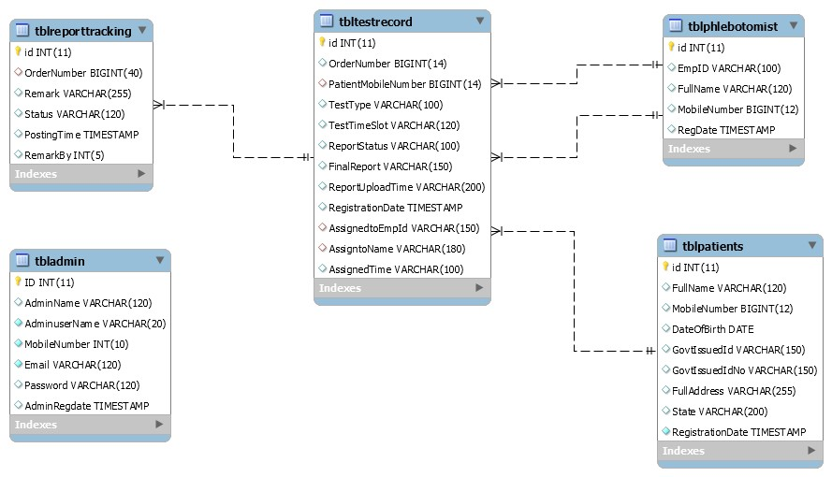

**3.5 ER Diagram:**

The Entity-Relationship (ER) model was originally proposed by Peter in 1976 [Chen76] as a way to unify the network and relational database views. Simply stated the ER model is a conceptual data model that views the real world as entities and relationships. A basic component of the model is the Entity-Relationship diagram which is used to visually represent data objects. Since Chen wrote his paper the model has been extended and today it is commonly used for database design for the database designer, the utility of the ER model is:

* + It maps well to the relational model. The constructs used in the ER model can easily be transformed into relational tables.
  + It is simple and easy to understand with a minimum of training. Therefore, the model can be used by the database designer to communicate the design to the end user.

In addition, the model can be used as a design plan by the database developer to implement a data model in specific database management software.

##### ER Notation

There is no standard for representing data objects in ER diagrams. Each modeling methodology uses its own notation. The original notation used by Chen is widely used in academics texts and journals but rarely seen in either CASE tools or publications by non-academics. Today, there are a number of notations used; among the more common are Bachman, crow's foot, and IDEFIX.

All notational styles represent entities as rectangular boxes and relationships as lines connecting boxes. Each style uses a special set of symbols to represent the cardinality of a connection. The notation used in this document is from Martin. The symbols used for the basic ER constructs are:

* **Entities** are represented by labeled rectangles. The label is the name of the entity. Entity names should be singular nouns.
* **Relationships** are represented by a solid line connecting two entities. The name of the relationship is written above the line. Relationship names should be verbs
* **Attributes**, when included, are listed inside the entity rectangle. Attributes which are identifiers are underlined. Attribute names should be singular nouns.
* **Cardinality** of many is represented by a line ending in a crow's foot. If the crow's foot is omitted, the cardinality is one.

**Existence** is represented by placing a circle or a perpendicular bar on the line. Mandatory existence is shown by the bar (looks like a 1) next to the entity for an instance is required. Optional existence is shown by placing a circle next to the entity that is optional.

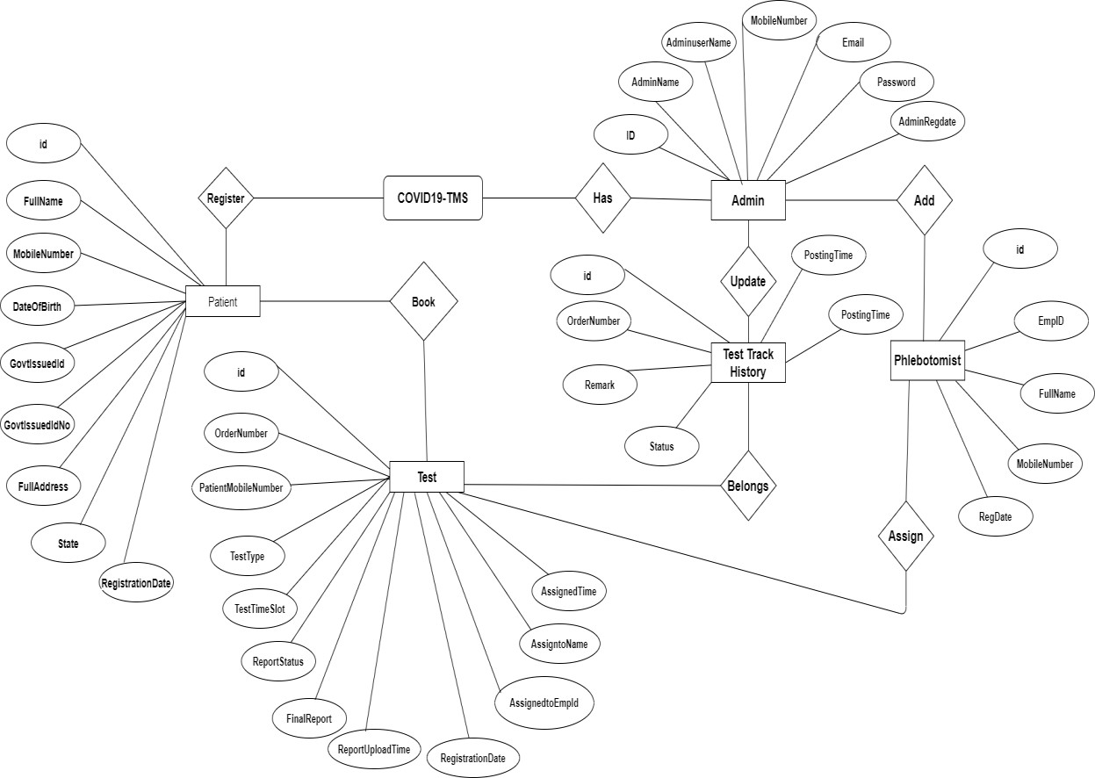

**CHAPTER 4:**

**DATABASE IMPLEMENTATION**

#### MySQL Data Tables

**Admin Table:**(Table name is tbladmin)

This store admin personal and login details.

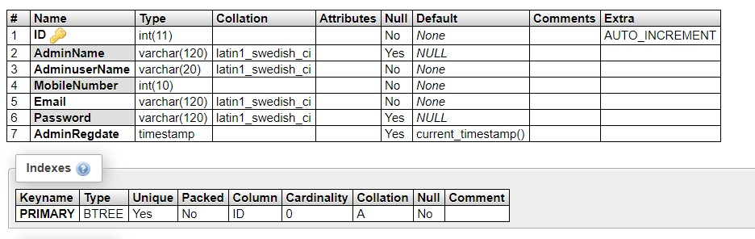

#### tblpatients

This table store the data of patient personal Information.

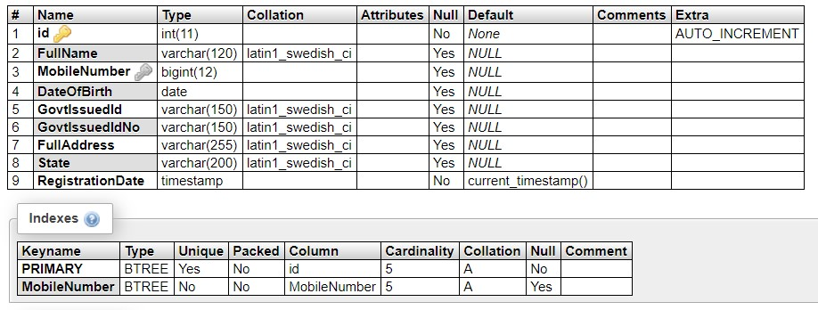

#### Tbltestrecord

#### This table stores the patient test record details.

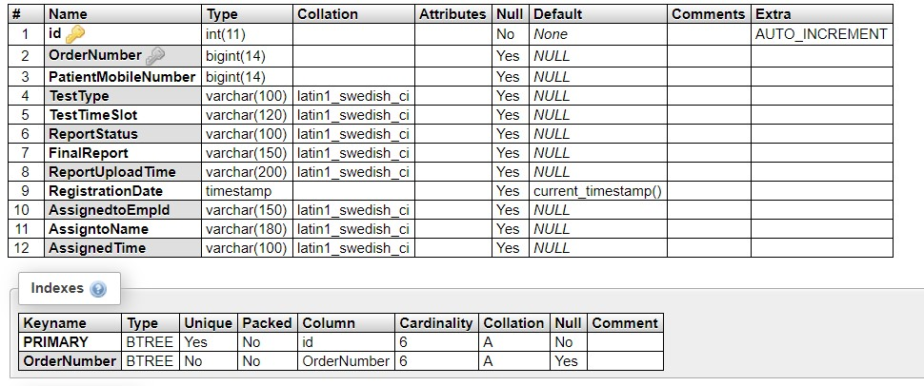

#### Tblreporttracking

#### This table stores the tracking details of tests.

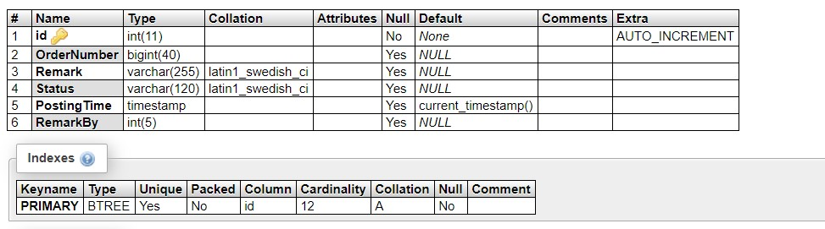

#### tblphlebotomist

This table stores the phlebotomist information.

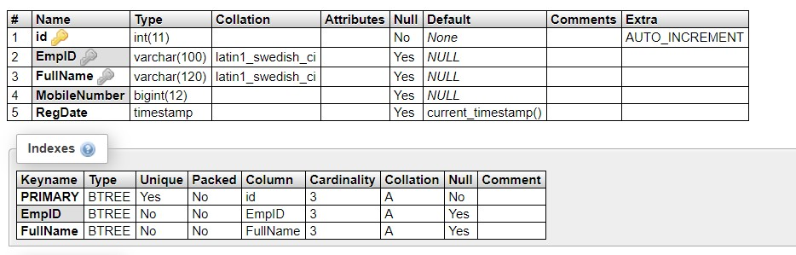

**CHAPTER 5:**

**IMPLEMENTATION AND SYSTEM TESTING**

After all phase have been perfectly done, the system will be implemented to the server and

the system can be used.

#### System Testing

The goal of the system testing process was to determine all faults in our project .The program was subjected to a set of test inputs and many explanations were made and based on these explanations it will be decided whether the program behaves as expected or not. Our Project went through two levels of testing

1. Unit testing
2. Integration testing

#### 5.1 UNIT TESTING

Unit testing is commenced when a unit has been created and effectively reviewed .In order to test a single module we need to provide a complete environment i.e. besides the section we would require

* The procedures belonging to other units that the unit under test calls
* Non local data structures that module accesses
* A procedure to call the functions of the unit under test with appropriate parameters

##### Test for the admin module

* **Testing admin login form:** This form is used for log in of administrator of the system.

In this form we enter the username and password if both are correct administration page will open otherwise if any of data is wrong it will get redirected back to the login page and again ask the details.

* **Report Generation:** admin can generate report from the main database.

#### 5.2 INTEGRATION TESTING

In the Integration testing we test various combination of the project module by providing the input.

The primary objective is to test the module interfaces in order to confirm that no errors are occurring when one module invokes the other module.

**CHAPTER 6**

**EVALUATION**

#### Project URL: http://localhost/covid-19tms

##### Home Page

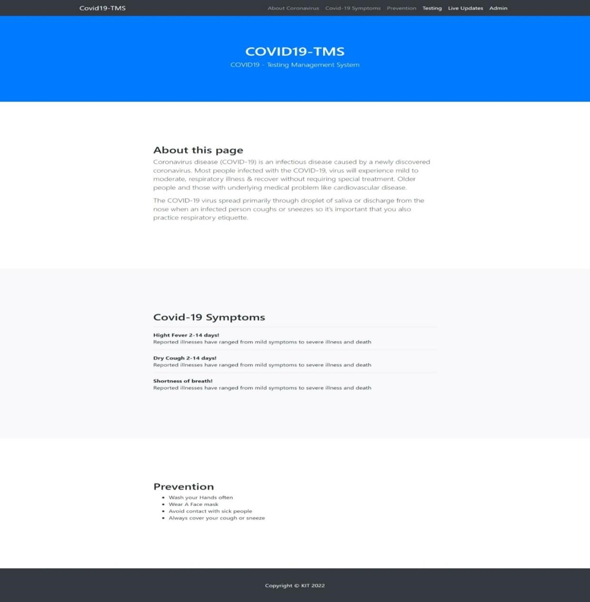

##### New User (Patient) Test Booking

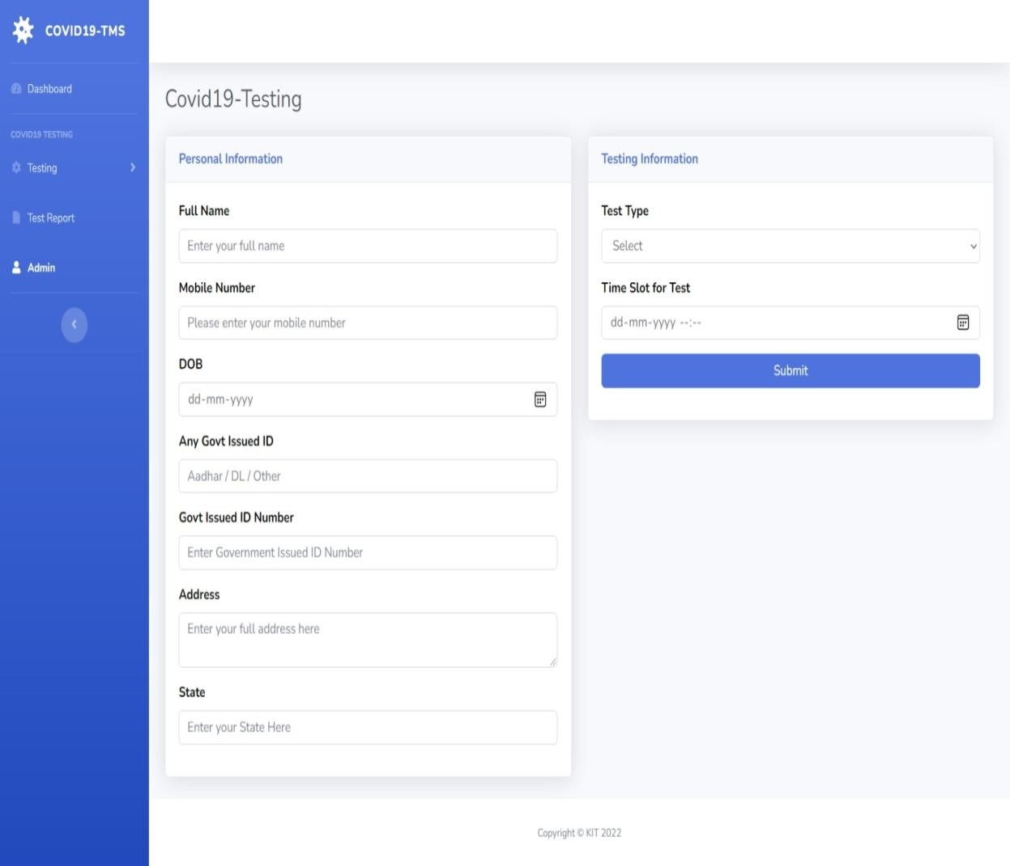

##### Already Registered User (Patient) Test Booking

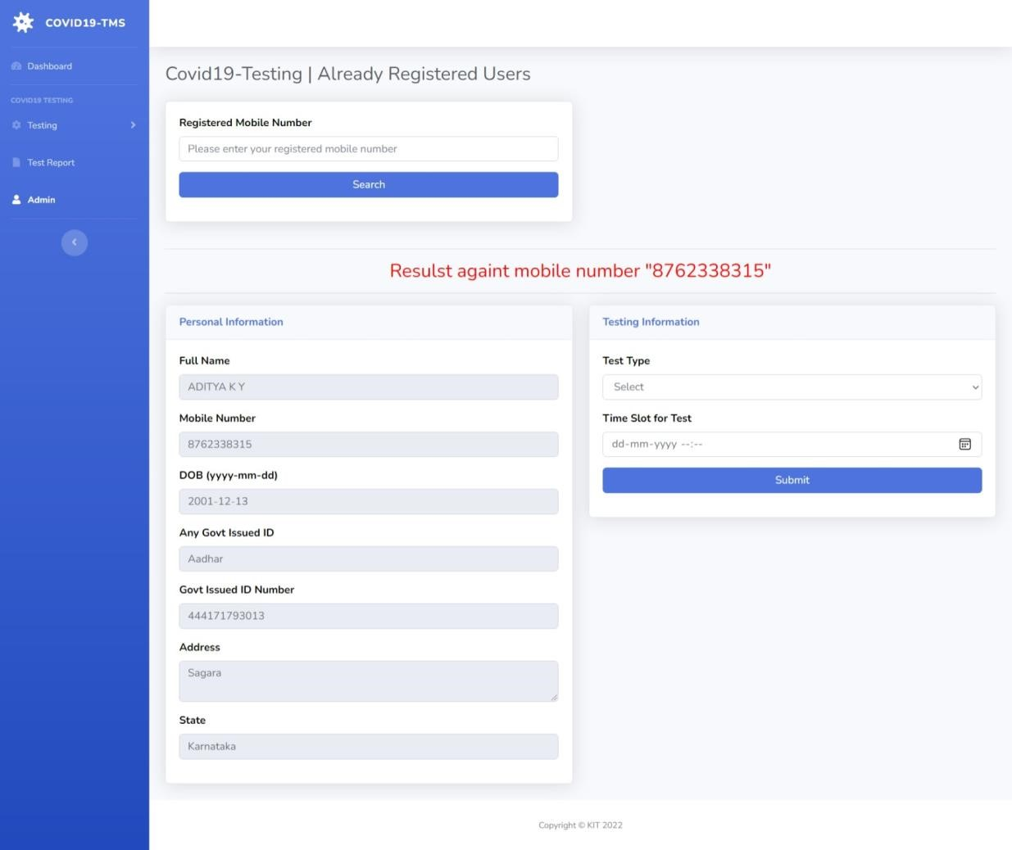

##### User (Patient) Test Details

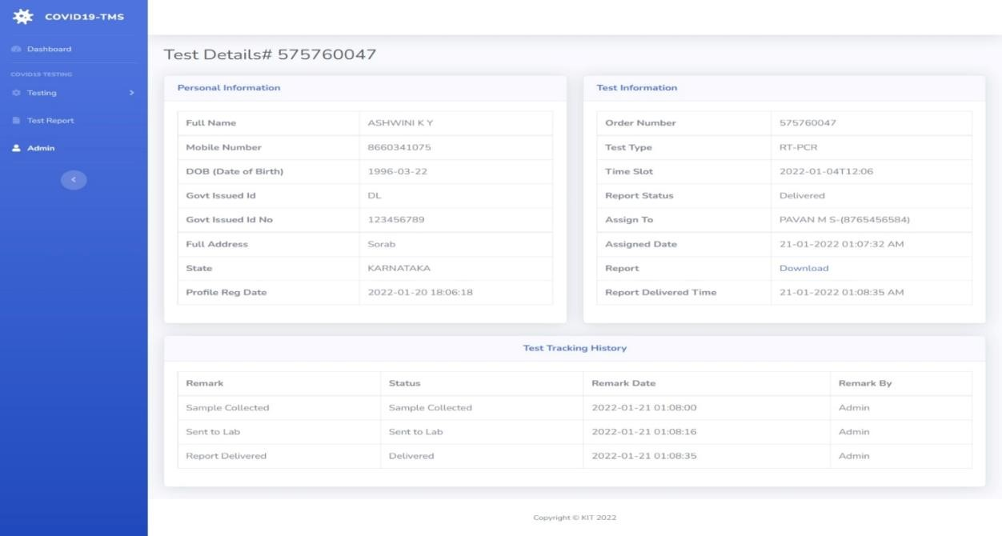

##### State Wise Dashboard

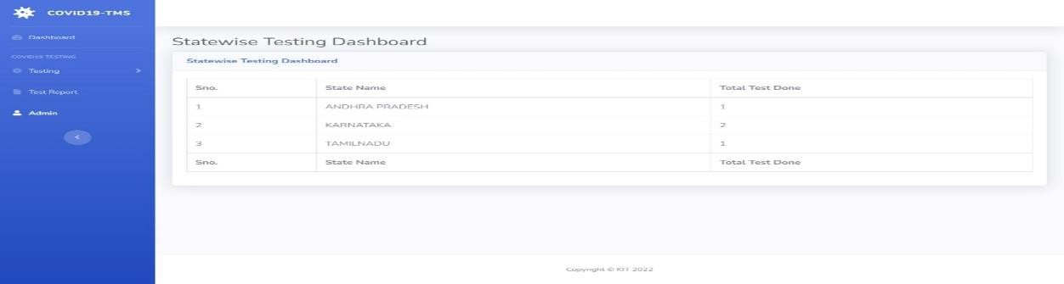

##### Admin Login

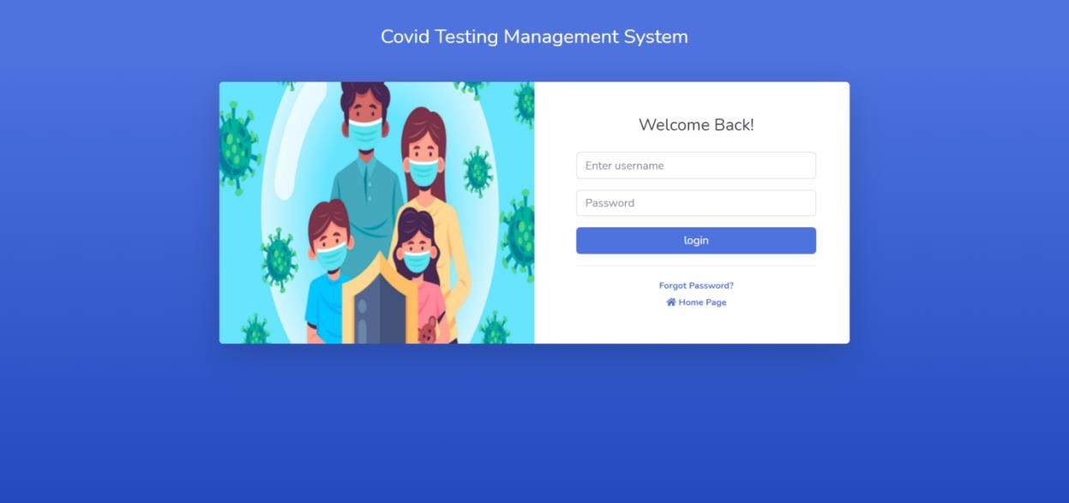

##### Admin Password Recovery

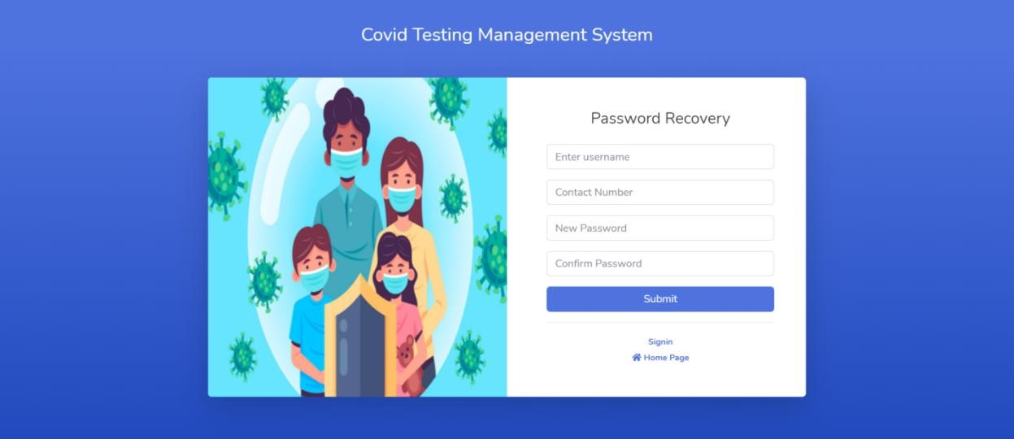

##### Admin Dashboard

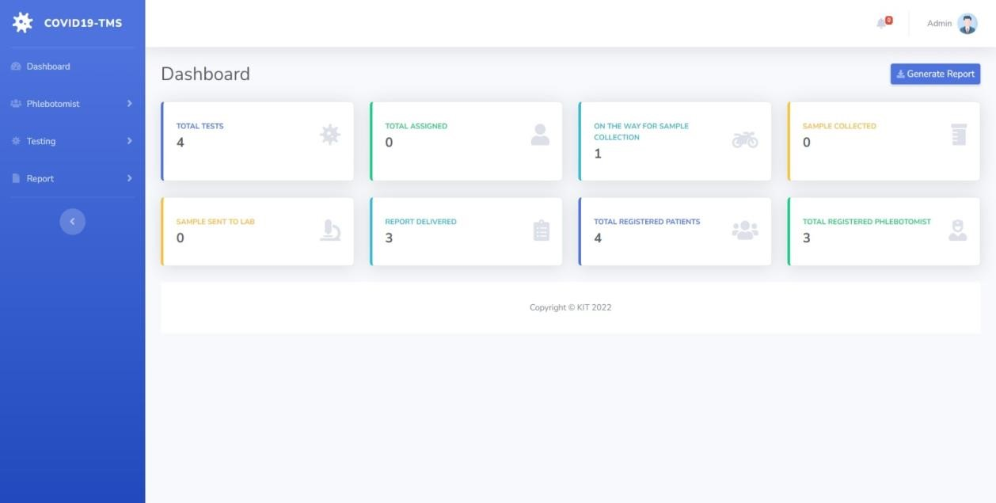

##### Admin Notification

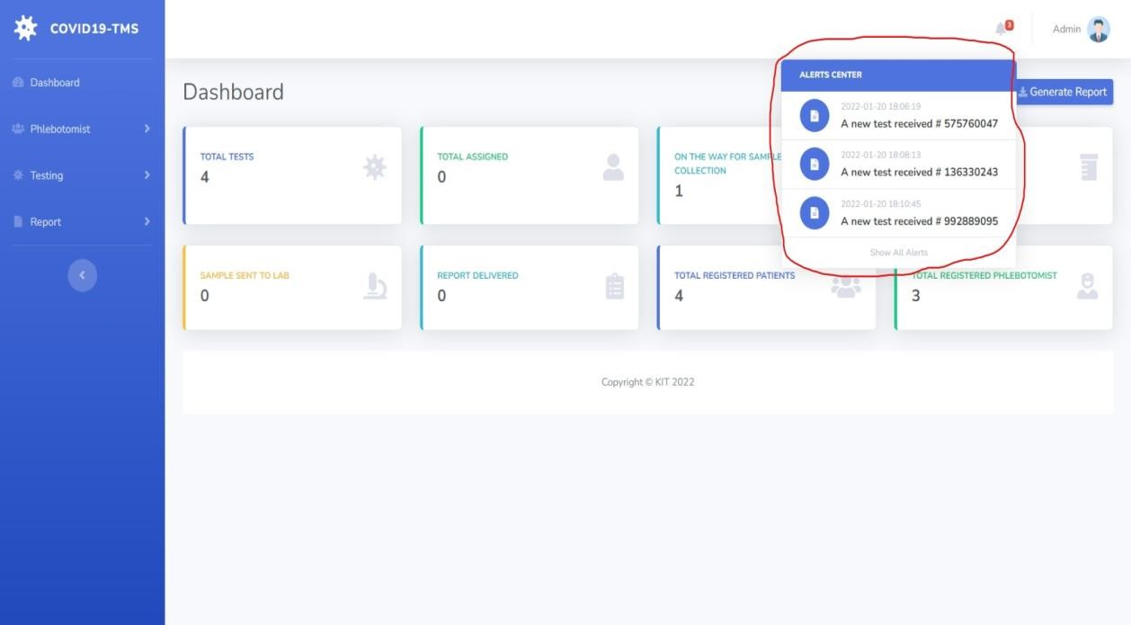

##### Add Phlebotomist

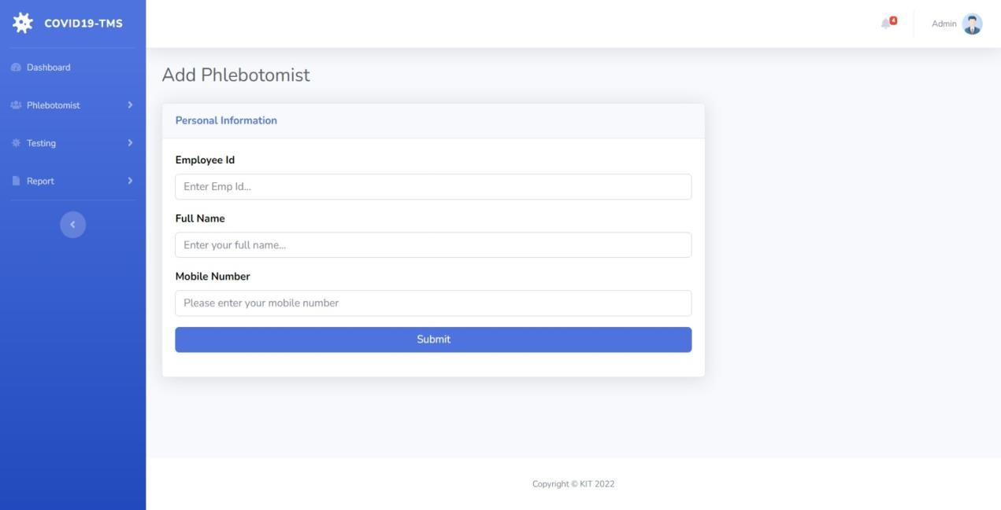

##### Manage Phlebotomist

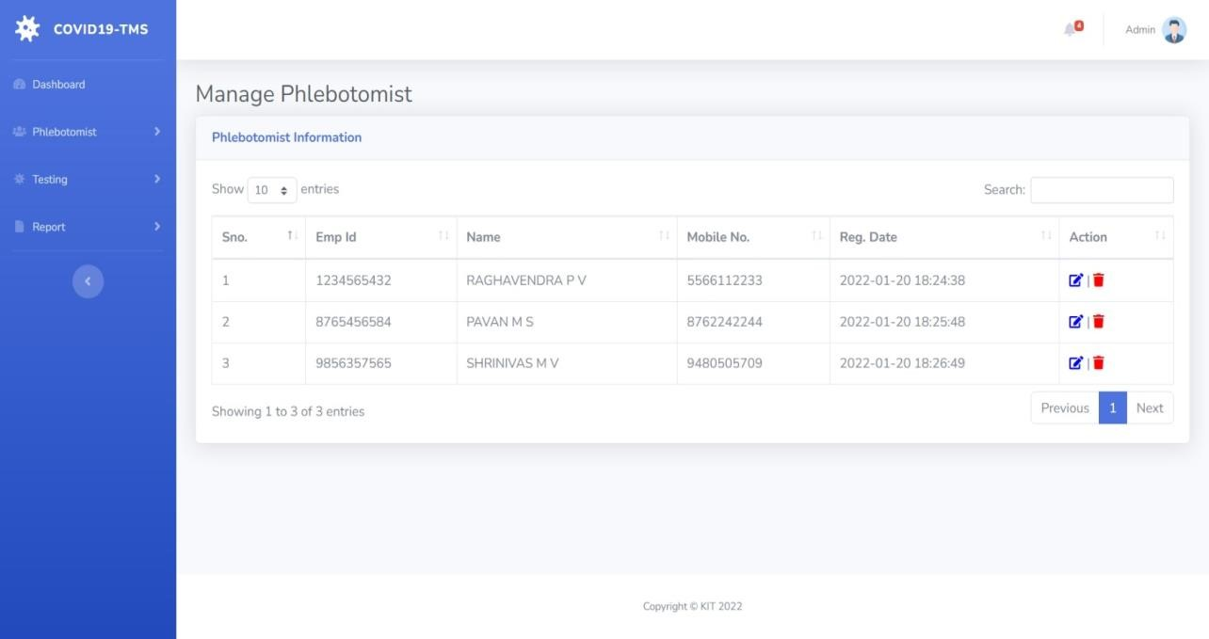

##### Edit/Update Phlebotomist Information

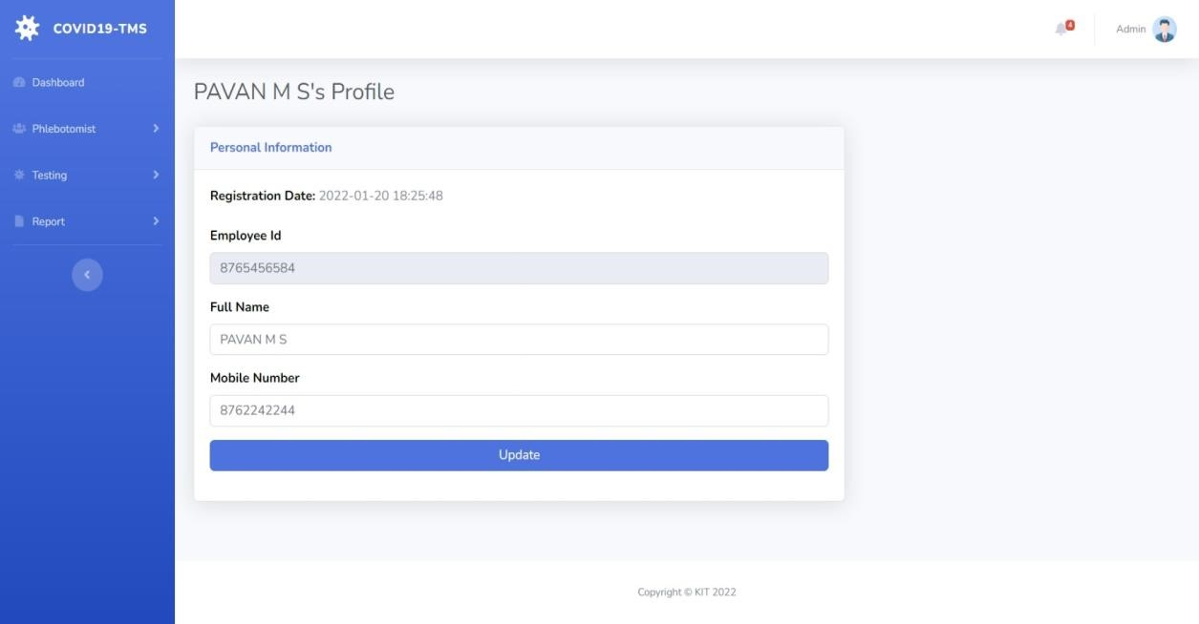

##### New/Assigned/On the way for collection/Sample Collected /Sent to Lab /Delivered / All Tests

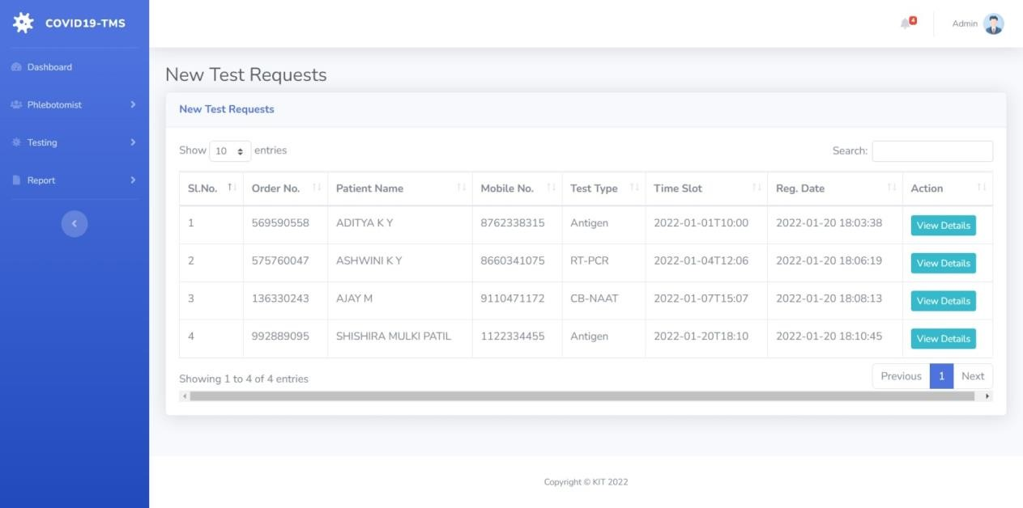

##### Test Details-1

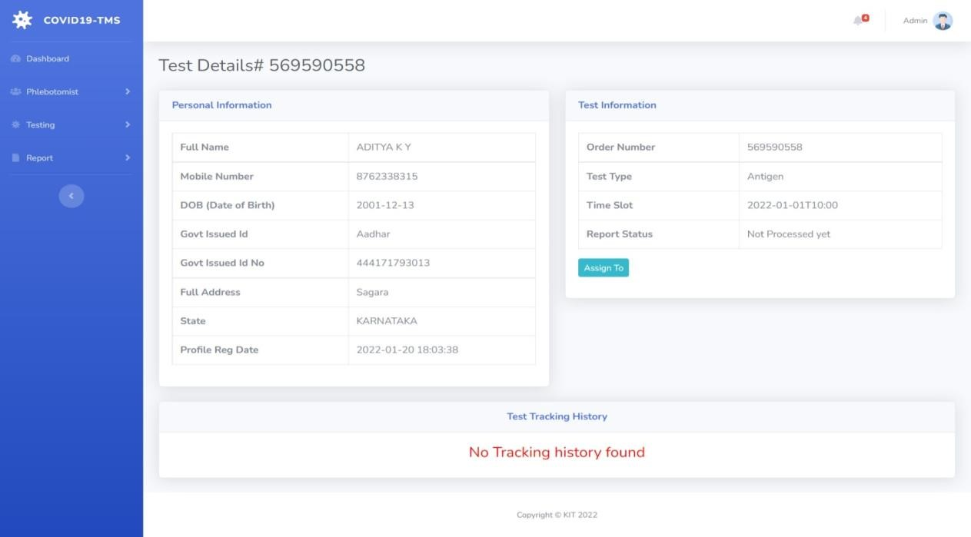

##### Assigned to

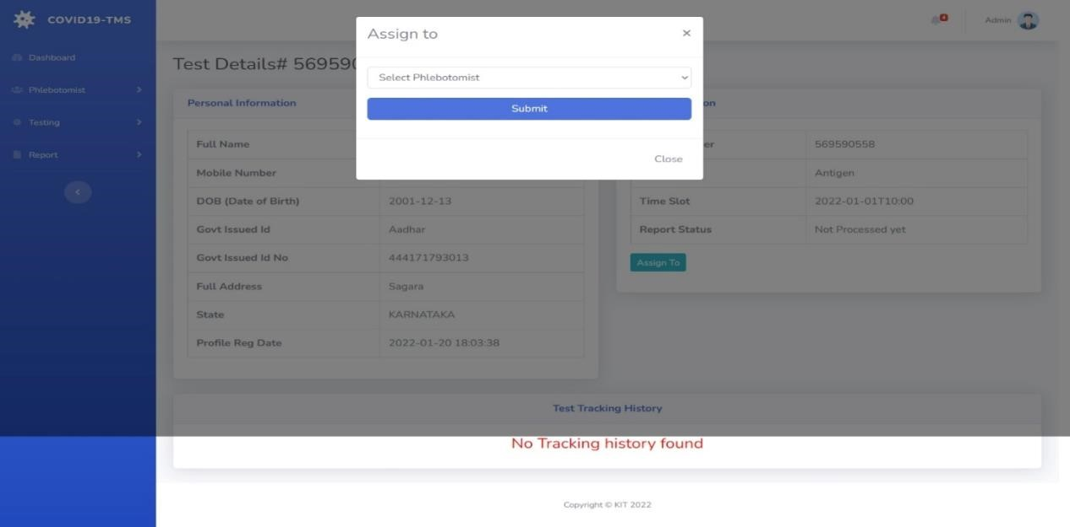

##### Take Action

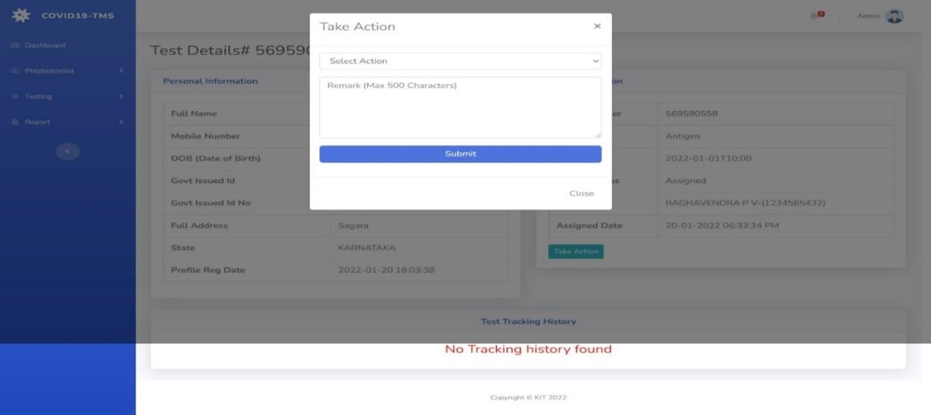

##### Test Details Admin

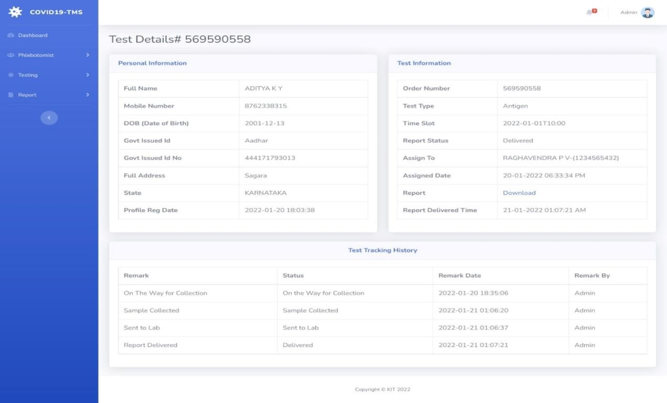

**Reports**

**B/w Dates Report Date Selection**

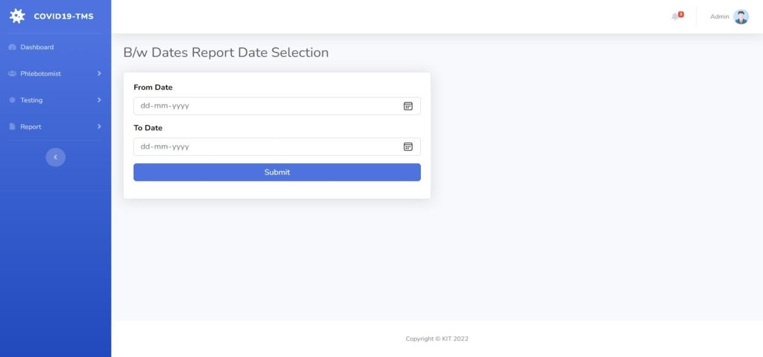

##### B/w Dates Test Result

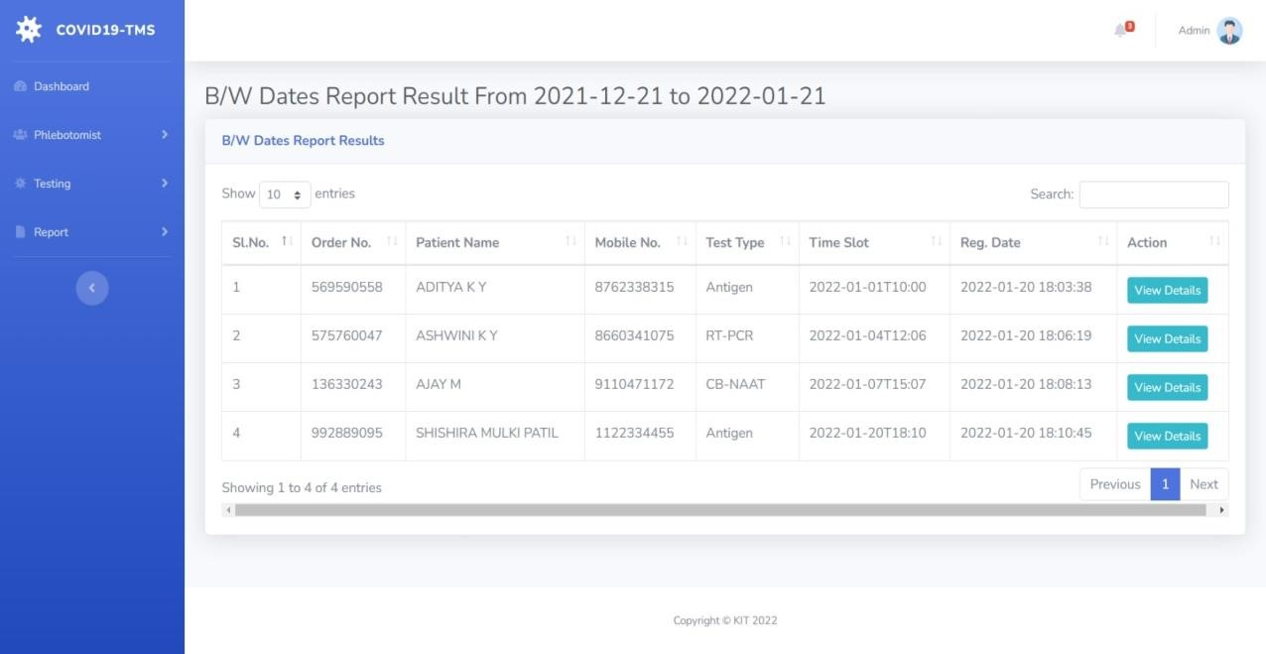

##### Search Report

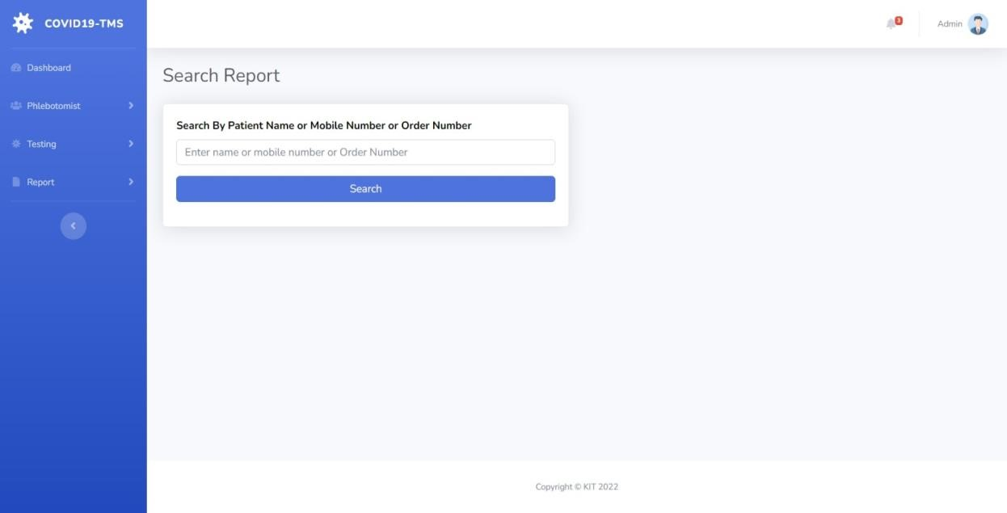

##### Search Report Result

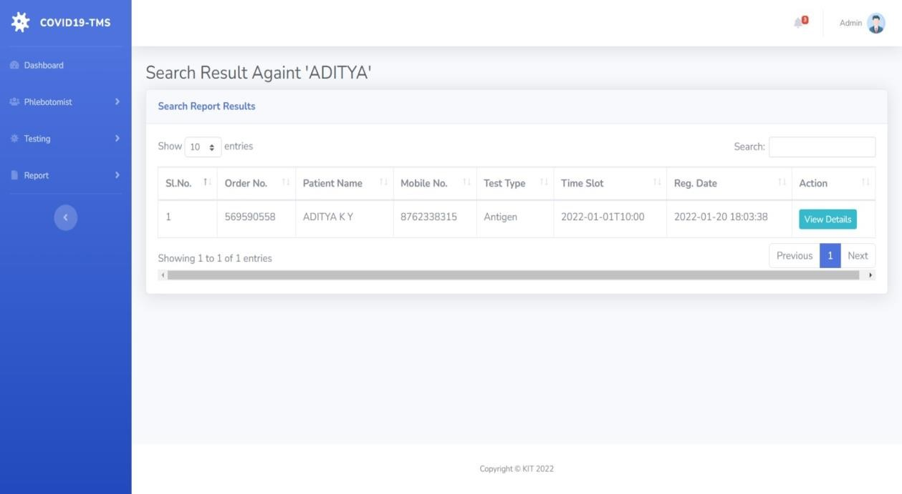

**Admin Profile**

**Admin Change Password**

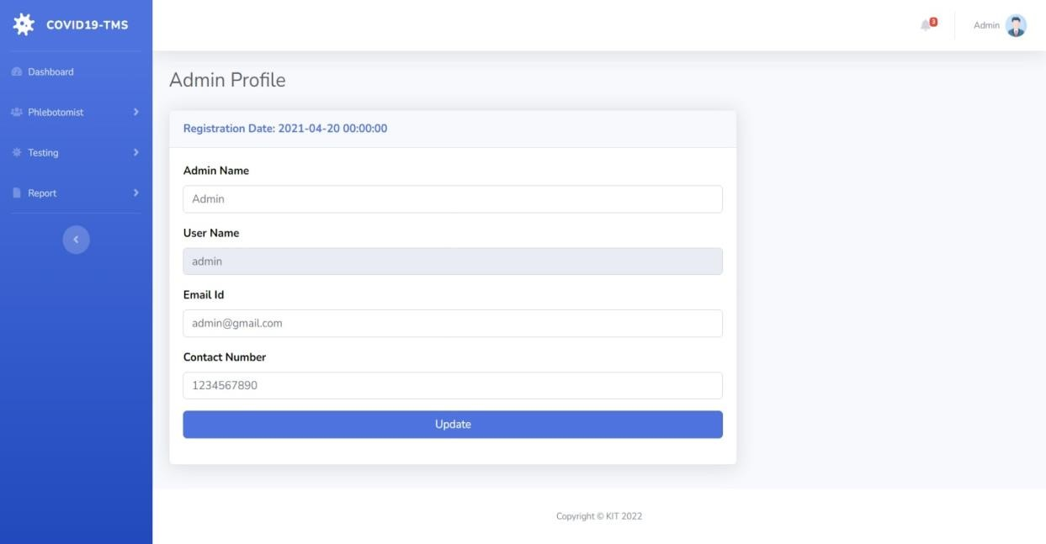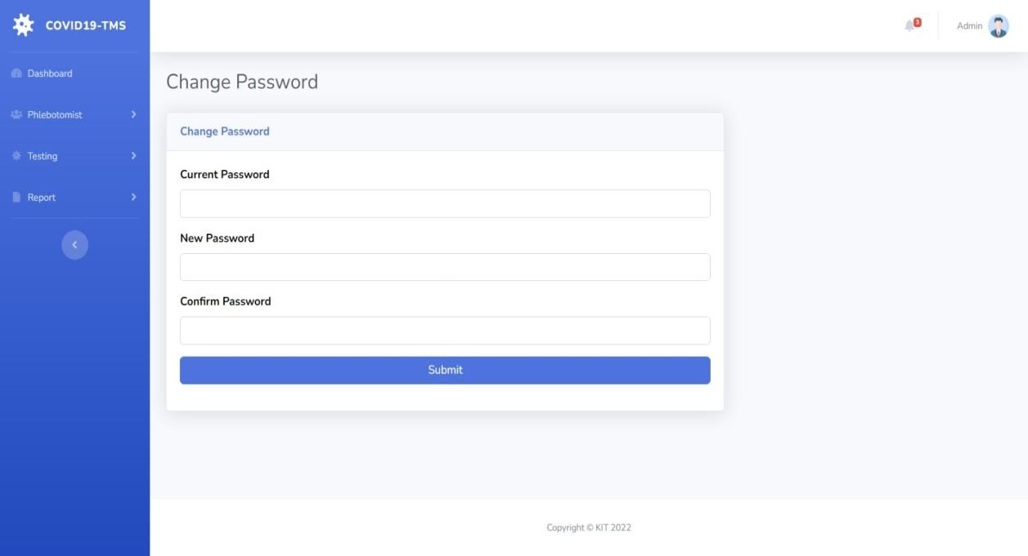

##### Admin Logout

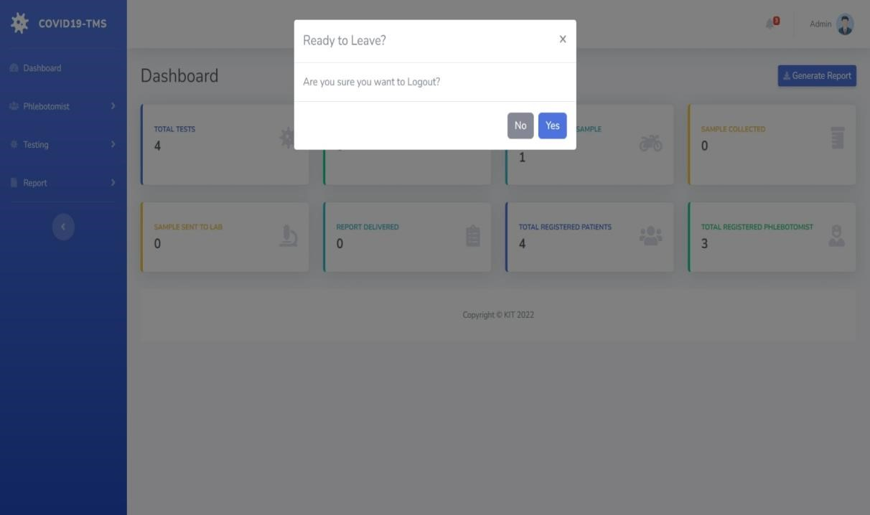

**CHAPTER 7**

**CONCLUSION**

COVID19 Testing Management System is very much graceful and lively. Patients have to register to the portal by giving their details and then they can take appointment through online with minimal effort. The Phlebotomist comes to patient address to collect the sample. Once test is done and test report is generated patient can download the report by logged in to the portal. This system can be implemented in diagnostic labs and clinics.

* Automation of the entire system improves the productivity.
* It provides a friendly graphical user interface which proves to be better when compared to the existing system.
* It gives appropriate access to the authorized users depending on their permissions.
* It effectively overcomes the delay in communications.
* Updating of information becomes so easier.
* System security, data security and reliability are the striking features.

The System has adequate scope for modification in future if it is necessary.

**CHAPTER 8**

**FUTURE ENHANCEMENTS**

We have developed this web application for demo purpose. This project can be taken into product level in future. In future we can develop an android application such that all the people can easily use this in their mobile phones only and can take benefit of it. We can include the medicines and some basic treatment methods such that the positively reported people can take care of themselves for further treatments. We can make it cost effective to make this project as robust and comprehensible.

**REFERENCES**

#### For PHP

* <https://www.w3schools.com/php/default.asp>
* <https://www.sitepoint.com/php/>
* <https://www.php.net/>

#### For MySQL

* <https://www.mysql.com/>
* [http://www.mysqltutorial.org](http://www.mysqltutorial.org/)

#### For XAMPP

<https://www.apachefriends.org/download.html>



NAME : SPOORTHY N

USN : 1KI20CS104

BRANCH : COMPUTER SCIENCE AND ENGINEERING

INSTITUTE : KALPATARU INSTITUTE OF TECHNOLOGY

MOB NO : 9686026107

E-MAIL : spoorthynagaraj2003@gmail.com



NAME : CHAITHRA A R

USN : 1KI20CS022

BRANCH : COMPUTER SCIENCE AND ENGINEERING

INSTITUTE: KALPATARU INSTITUTE OF TECHNOLOGY

MOB NO : 9731012574

E-MAIL : chaithrakit.cse.2020@gmail.com